**Nama : Hafizah Safira Kaurani**

**Kode Peserta : FSDO003ONL001**

**Assignment 3 (Movies Database Project)**

**MoviesApi (Swagger)**

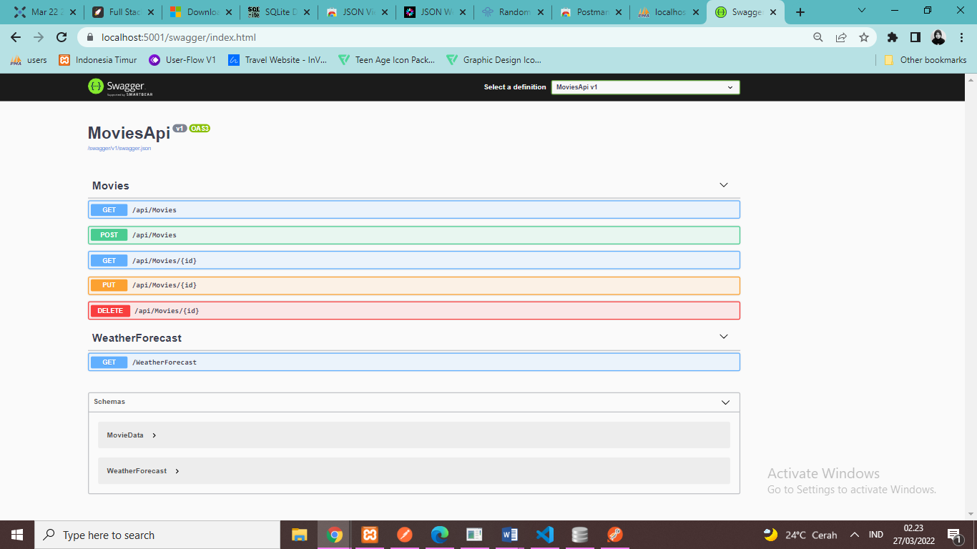*URL :* [*https://localhost:5001/swagger/index.html*](https://localhost:5001/swagger/index.html)

* 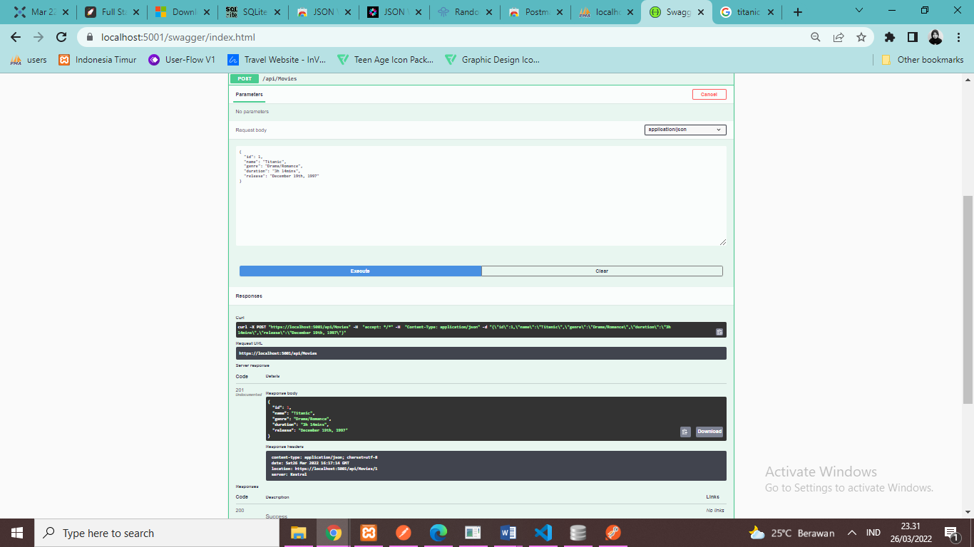POST /api/movies
* 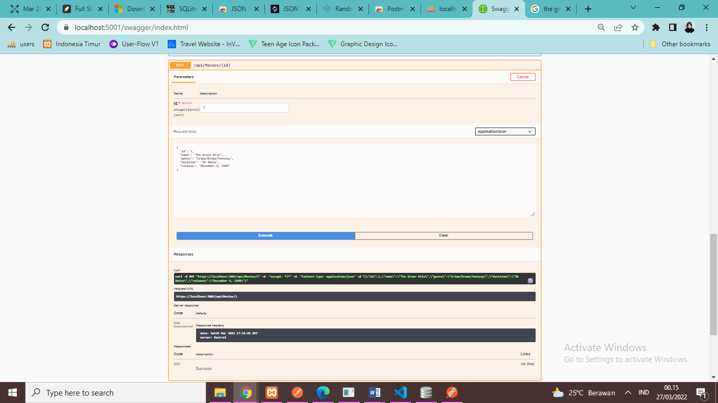PUT /api/movies/1
* 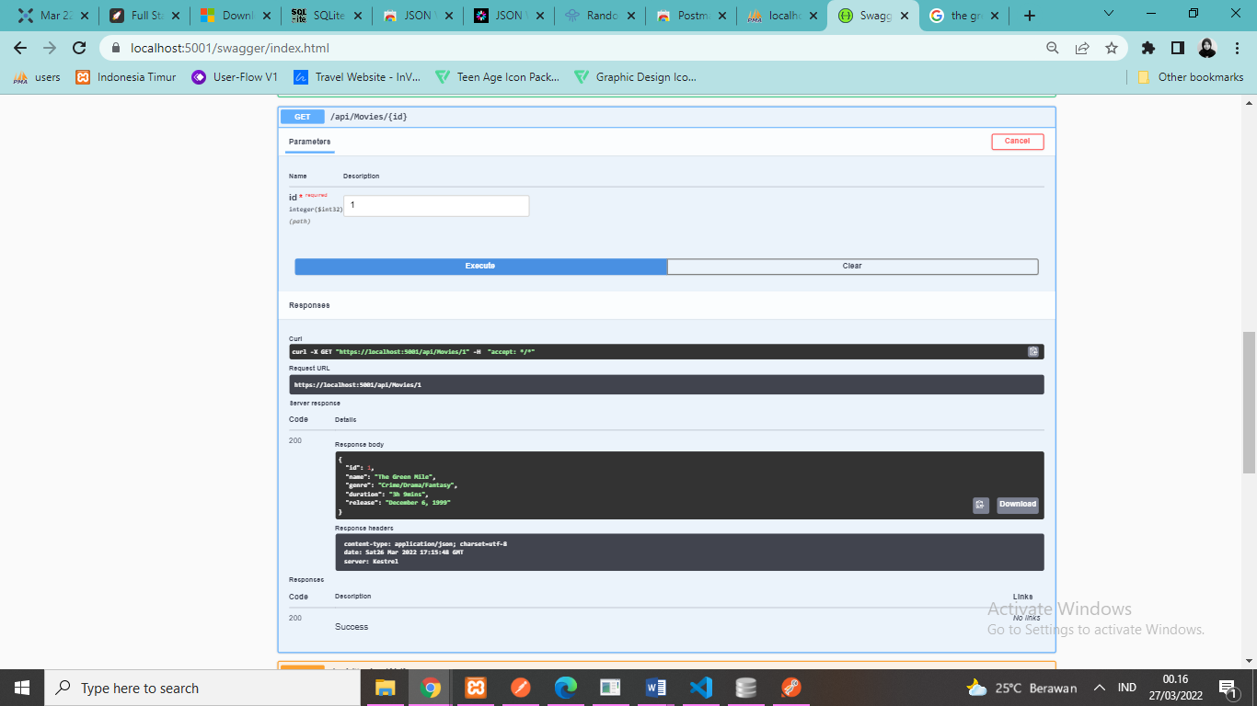GET / api/movies/1
* 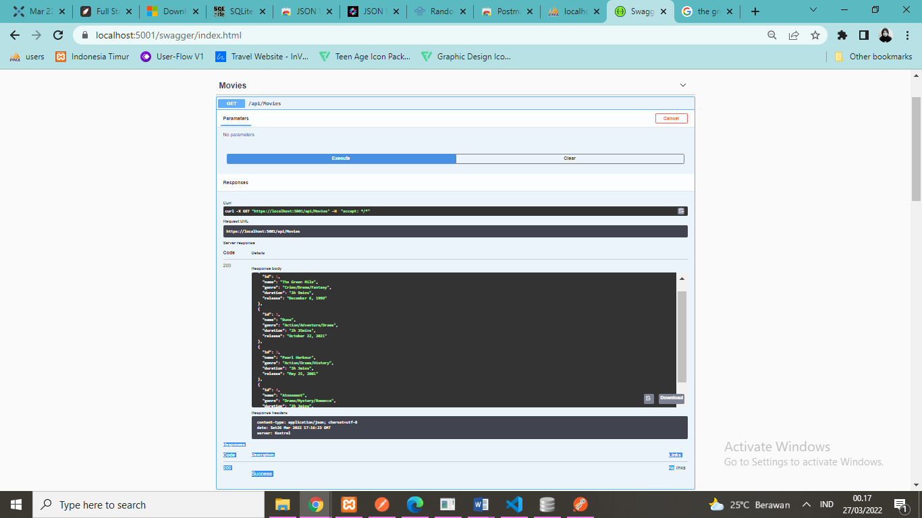GET /api/movies
* 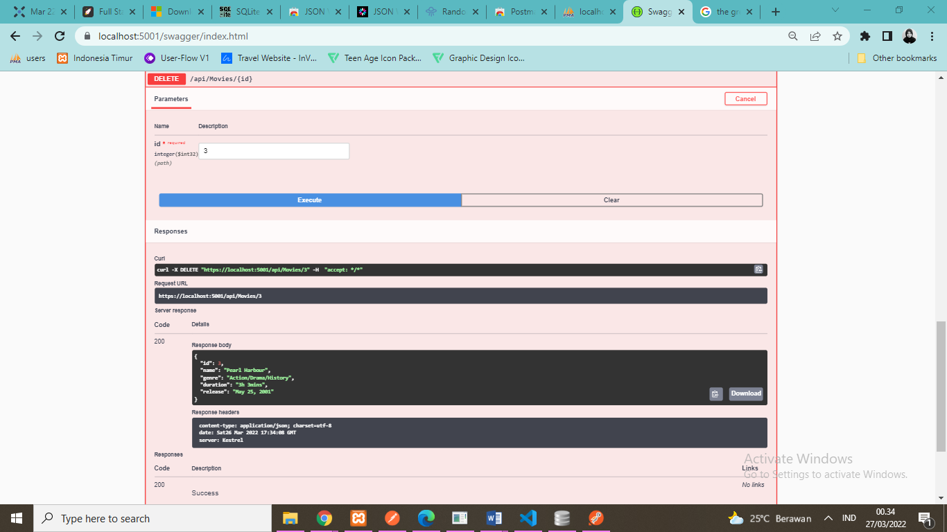DELETE /api/movies/3

**MoviesAPI (Postman)**

*URL : https://localhost:5001/api/movies*

* GET /api/movies

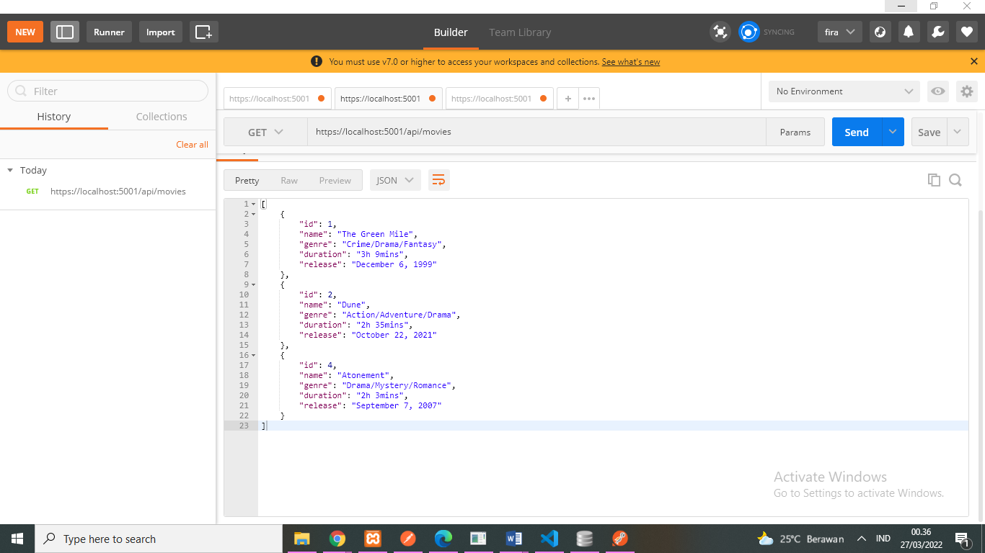

* GET /api/movies/2

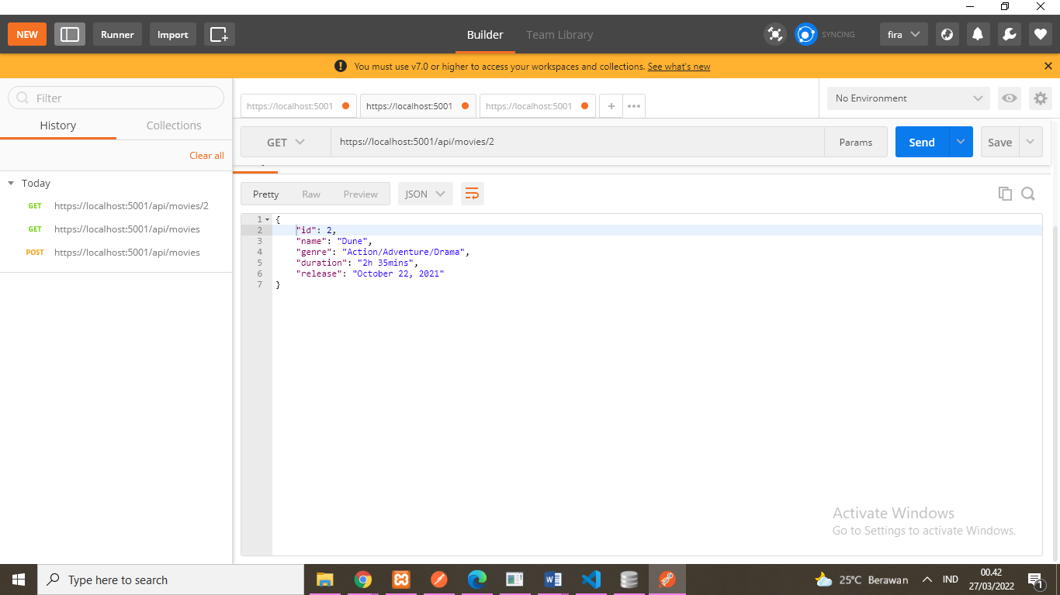

* POST /api/movies

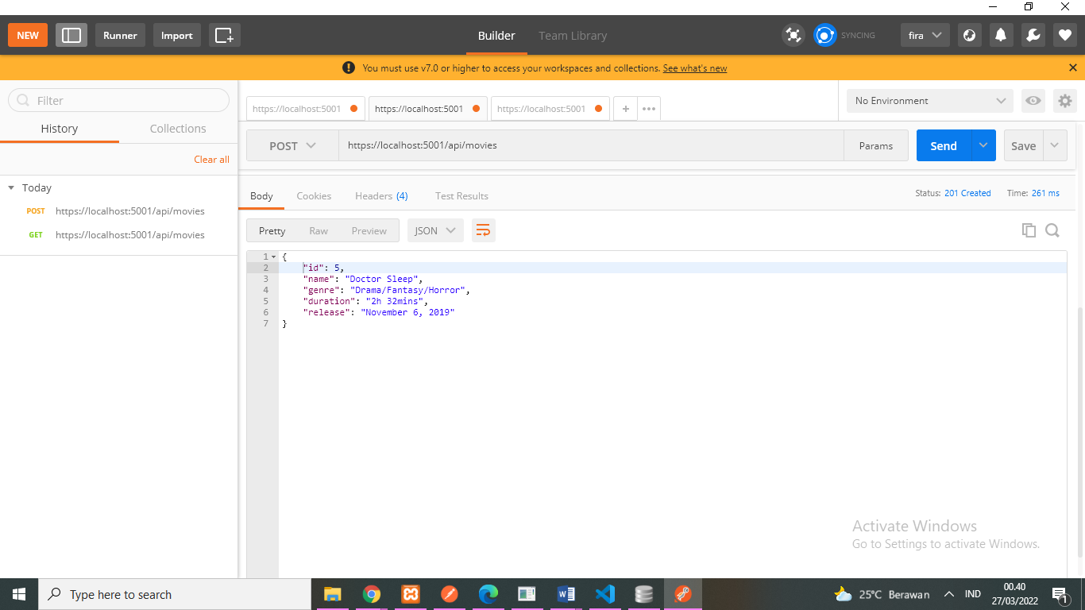

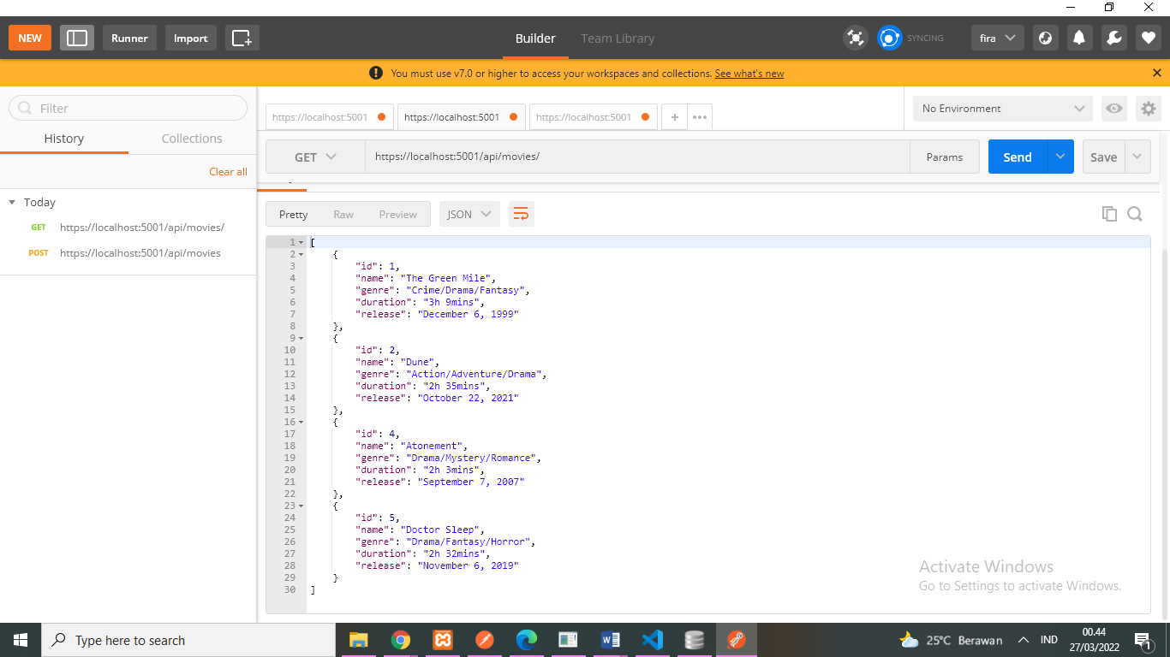

* PUT /api/movies/5

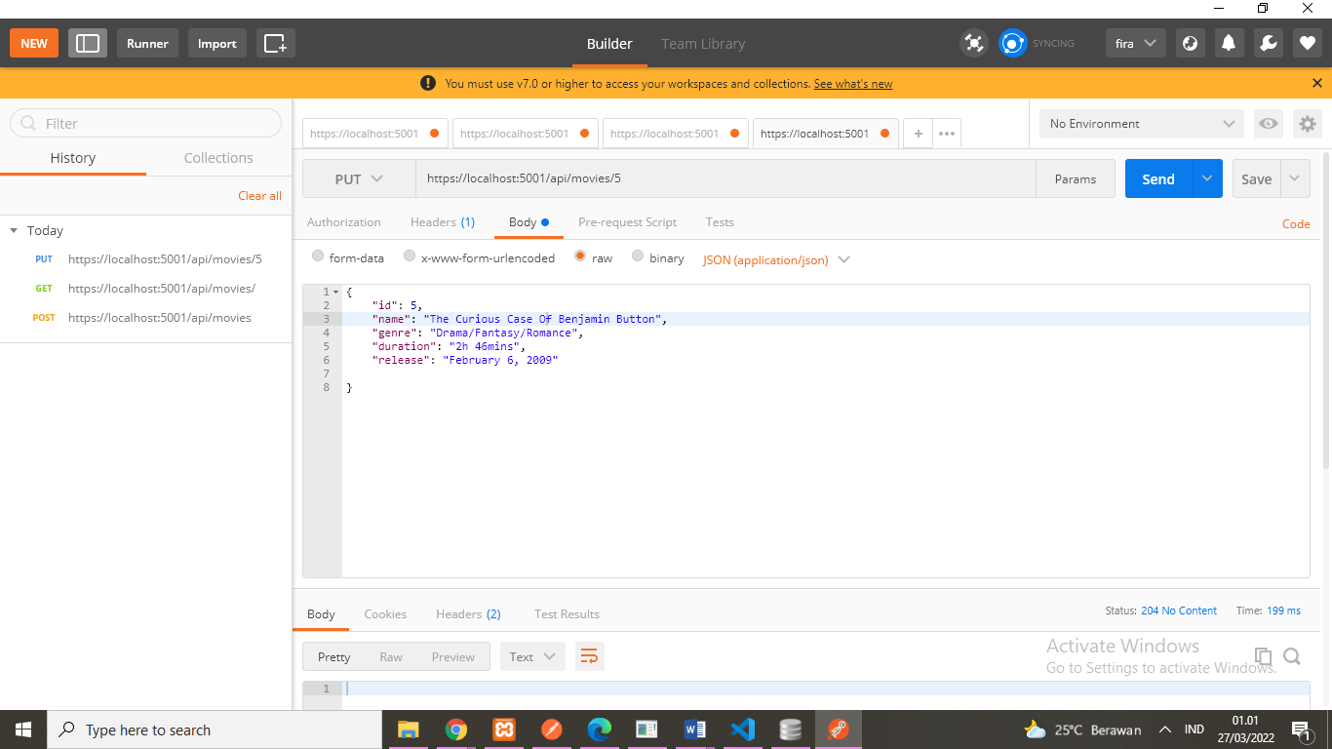

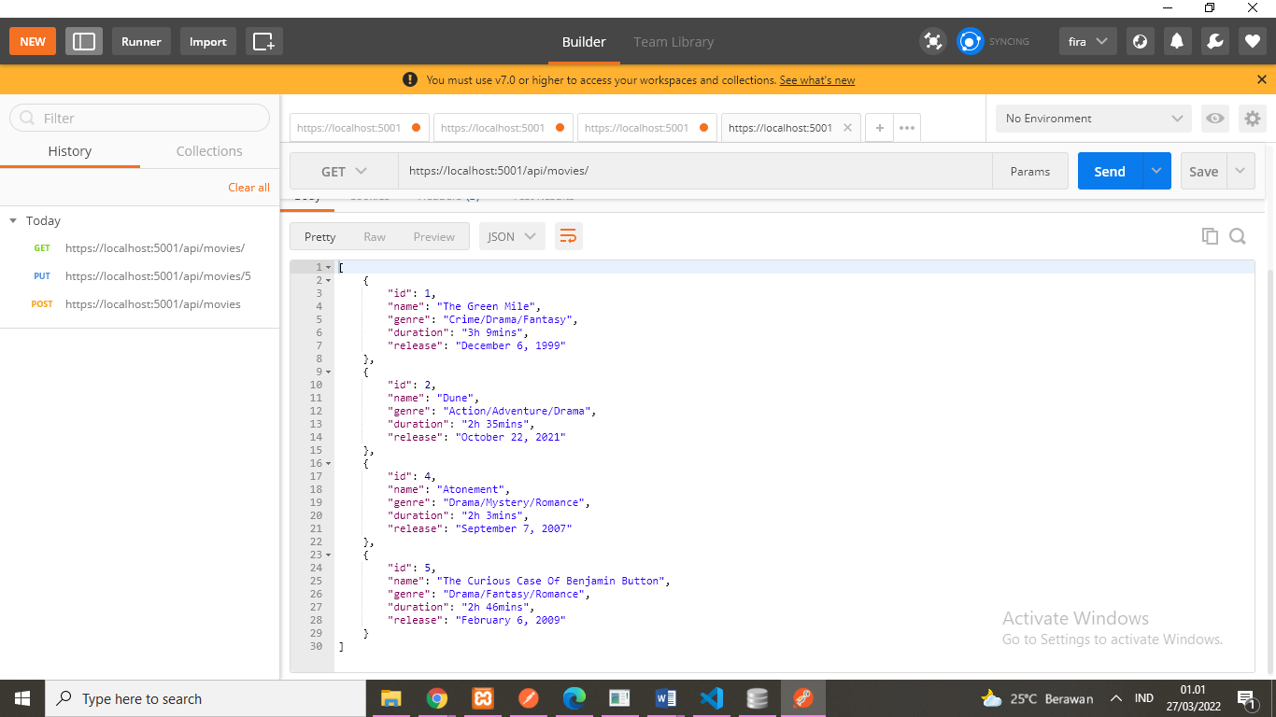

* DELETE /api/movies/5

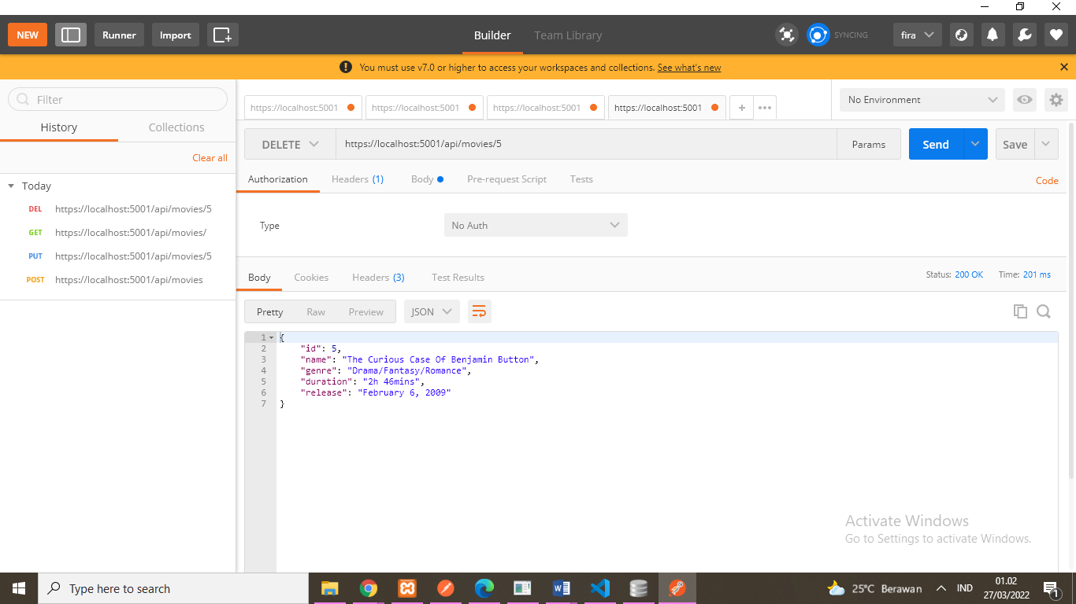

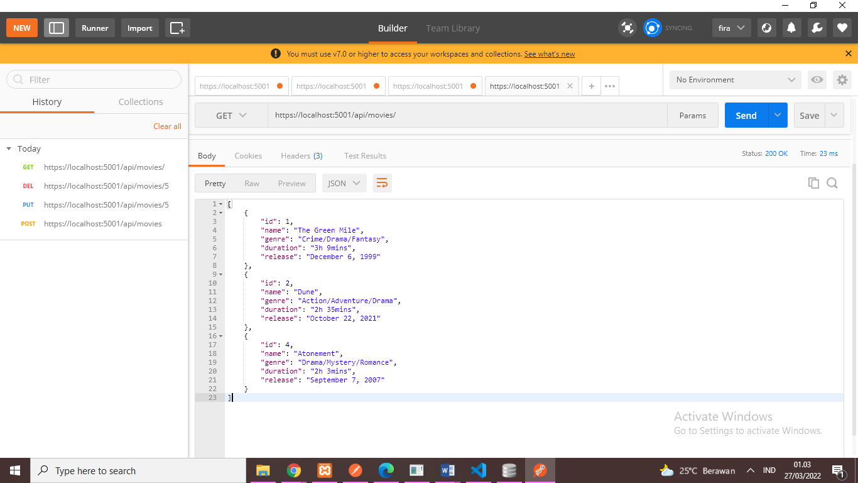

* Tampilan database movie

